ETL Project
Final Technical Report

Bee Colony Population vs Weather

12/21/2019

Submitted by
Jelly Ramos & Cristina Shary
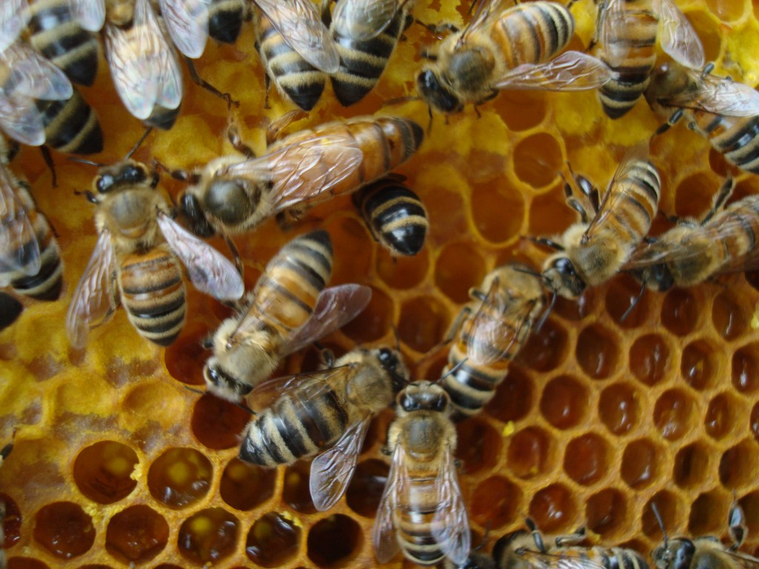

Introduction
We were asked to create an ETL project. This included extracting original data sources and describing how the data was transformed. During the transformation process, we must detail our process for cleaning the data, if it were needed. The final objective was to load the data into a database, tables or collections, and described why the specific method was chosen.

Description of Proposed Project
We wanted to look at the main causes of bee population decrease. As it currently stands, the sharp decrease of bees is a widely debated issue regarding what is the "true" root of the issue. It has been narrowed down to the following factors: Pesticides, Pathogens, Parasites, and Climate. Initially we had planned to compare all factors and calculate which had the highest correlation to the decrease of population. However, in order to keep within our given timeframe, we decided to solely zero in on the weather changes in relation to the population count which also had the best range of datasets available to us

Background Information
After searching the web extensively for datasets that we found online, we found some very useful studies and datasets that helped us narrow our objective. These resources include the following:
- https://towardsdatascience.com/whats-buzzing-with-the-bees-99f9be0bc4c6
- https://www.npr.org/sections/thesalt/2019/06/19/733761393/more-bad-buzz-for-bees-record-numbers-of-honey-bee-colonies-died-last-winter
- https://www.sciencedirect.com/science/article/abs/pii/S0167880919302105
- https://data.world/finley/bee-colony-statistical-data-from-1987-2017
- https://data.giss.nasa.gov/gistemp/tabledata_v4/NH.Ts+dSST.txt

General Project Study Area
We focused on extracting the Northern Hemisphere weather data, which consisted of mean land/sea temperatures, and the total count of bee population observations in the US during a certain timeframe.

Process
Before we could begin collecting our data, we needed to create a GitHub repo where the both of us had access and could contribute to it: https://github.com/HoneyBumbleBeez
We also created a google drive which housed our ideas, proposal and various notes about how we were going to complete this project.
Once we cloned our Git to our desktops and pushed our files up to the repo, we were able to smoothly merge our commits. The next step would be to address any cleaning of the data.

Issues and Concerns

The Bee Colony Count File
The Bee Colony file was originally an Excel file, so we were unable to read it as a CSV with Pandas until we changed the extension. Once we exported the file to a CSV format, we were able to import and preview the data on Jupyter Notebook. We realized there was a need to drop all of the unnecessary columns which included: Week Ending, State ANSI, Watershed, CV (%) using this code: NewBee = BS_df.drop(['Week Ending', 'State ANSI', 'Watershed', 'CV (%)'], axis =1)
The next step was to rename some of the columns to simplify our data. We changed two select columns names to ‘Data’ and ‘Count’. We then had to drop data that we would not be able to use so we removed certain rows entirely that did not reflect the inventory of the bees sampled at that time.
Since we knew that we wanted to join our datasets on two columns, it was necessary to apply the groupby function for the column ‘Year’ and ‘Period’. We then had to remove all the cells in the ‘Period’ column that didn’t display data for any three consecutive months. Next, we had to convert the ‘Count’ column from a string to an integer. However, we also had to make sure that we removed all non-numeric characters to make the conversion successful. Once the column had been changed to integers, we were able to apply the sum function to find out the population count of bee colonies for an isolated timeframe. The last steps involved exporting the file back to an excel file and then uploading it to GitHub.

The Weather File
The original file for the dataset had come with a header that, when converted into a Pandas data frame, was unreadable. So, the first step was to remove it manually in Excel. Once that was done, we were looking at a set containing the land-ocean global mean temperature for every month and season from the year 1880 to 2019. For the purpose of our project, we needed to create a like column between the Colo0ny Count file and the Weather file. We decided on matching the year in conjunction with the period. However, because the Weather file’s data was split into months, we had to pass the numbers through a mean function and get the three-month-period to match up with the pre-existing column from the Colony Count file.
After grouping and rounding the data to match the original format. The last steps were to convert the numbers into more conventional units of temperature and grouping the data. This was simple enough as the numbers were only changed by a factor of 100 from degrees in Celsius. We did not want to convert to Fahrenheit to keep within the metric system.
After converting the units, we then joined our data on both ‘Year’ and ‘Period’ and concatenated it to the years both tables had in common. We finally exported this file into its own respective CSV file (BeeMerged) to be uploaded to pgAdmin4.

Goals and Objectives
Now that both datasets were cleaned and uploaded to GitHub, we then exported the data to a CSV file. We then created a table on pgAdmin4 to merge our datasets. As we had predicted, we were able to see a direct correlation between bee colonies and weather. In short, we found that when the average temperature of the Northern Hemisphere dropped, so did the population of bee colonies across the United States.

Opportunities for Enhancement
Because of the tight deadline, we had to forego our desire to compare the population of bee colonies against datasets that tracked known pathogens, parasites and pesticides that we suspect would have had a great effect on the overall population count for specific regions/timespans.
We would have also liked to have had more years available for the bee population count since the weather data was so extensive. With more years, we would have been able to see more accurate trends and even anomalies. Perhaps our conclusions would have changed with more data.
Lastly, if given more time, we would have liked to create graphics using matplotlib to represent the merged datasets.

Loading

Loading

SQL – pgAdmin4
While we joined the tables through Jupyter Notebook on the columns of Year and Period, our intention was to also join the tables through a SQL database query. Once we had our cleaned CSV files ready to import to a SQL database, we prepared pgAdmin4 to accept the csv files by creating the necessary tables. We had to create a primary key for each table and match all the columns for importing. Once the tables were created, we had to copy the CSV information in by importing the files. To display the tables, we queried the data to show all rows. We also snapshotted the images of the tables displayed and saved our query SQL files for viewing to complete the final step of our ETL project. The images from the tables made in pgAdmin are at the end of this report.

Goals and Objectives
Now that both datasets were cleaned and uploaded to GitHub, we then exported the data to a CSV file. We then created a table on pgAdmin4 to merge our datasets. As we had predicted, we were able to see a direct correlation between bee colonies and weather. In short, we found that when the average temperature of the Northern Hemisphere dropped, so did the population of bee colonies across the United States.

Opportunities for Enhancement
Because of the tight deadline, we had to forego our desire to compare the population of bee colonies against datasets that tracked known pathogens, parasites and pesticides that we suspect would have had a great effect on the overall population count for specific regions/timespans.
We would have also liked to have had more years available for the bee population count since the weather data was so extensive. With more years, we would have been able to see more accurate trends and even anomalies. Perhaps our conclusions would have changed with more data.
Lastly, if given more time, we would have liked to create graphics using matplotlib to represent the merged datasets.

Images

Bee Colony Population table created in pgAdmin4:

(Continued)
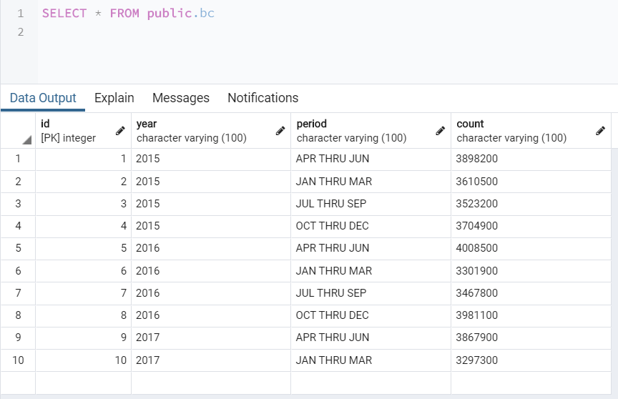

Weather Data table created in pgAdmin4:

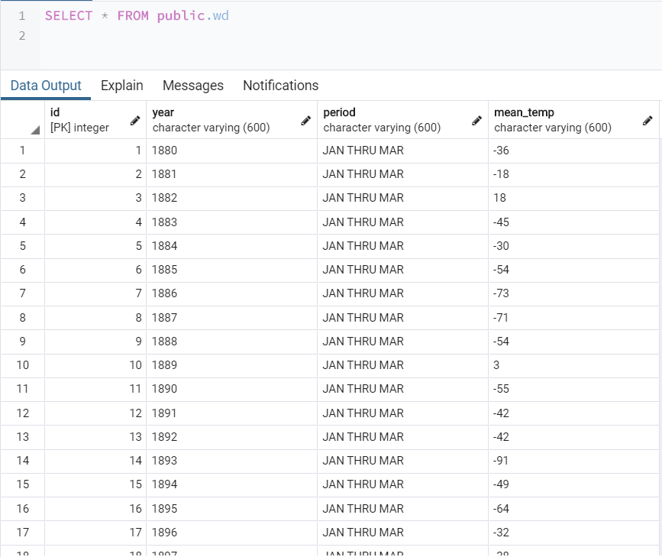

Merged Data table created in pgAdmin4:

